INTRODUCTION
  - Project Overview

The iRevolution project aims to explore and analyze the impact of Apple’s iPhone in the Indian market using powerful visual analytics. By leveraging Tableau, this project brings together multiple dimensions of iPhone-related data such as pricing, specifications, reviews, discounts, and market share to deliver clear, interactive dashboards. It transforms complex datasets into intuitive visual stories, helping stakeholders derive insights faster and more effectively.
  - Purpose
The main purpose of this project is to assist product analysts, marketing teams, and decision-makers in understanding how various iPhone models perform across different Indian regions and quarters. By using a data-driven approach, the project provides a platform to explore trends in sales, user preferences, and key performance indicators, thus encouraging smarter decision-making in pricing, promotion, and feature planning.

IDEATION PHASE

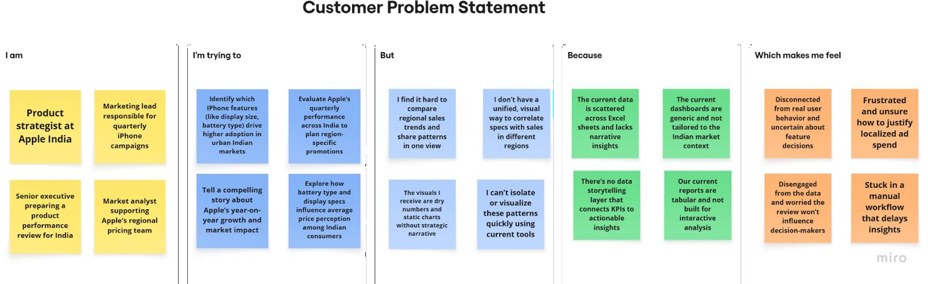
  - Problem Statement

Problem Statement (PS) | I am | I’m trying to | But | Because | Which makes me feel
PS-1 | a product strategist | find which iPhone features drive adoption in urban India | data is scattered and not visual | there's no unified dashboard | unsure about feature decisions
PS-2 | a marketing lead | track regional performance for iPhone campaigns | I can’t compare trends across quarters and states | dashboards  aren’t  India-specific | frustrated and uncertain on promotions
PS-3 | Senior executive | present iPhone growth in India clearly | reports lack storytelling and visual appeal | there’s no narrative-driv en dashboard | disengaged and ineffective
PS-4 | market analyst | link features like battery/display to price | I can’t visualize patterns easily | tools are static and not interactive | slowed down and stuck

  - Empathy Map Canvas
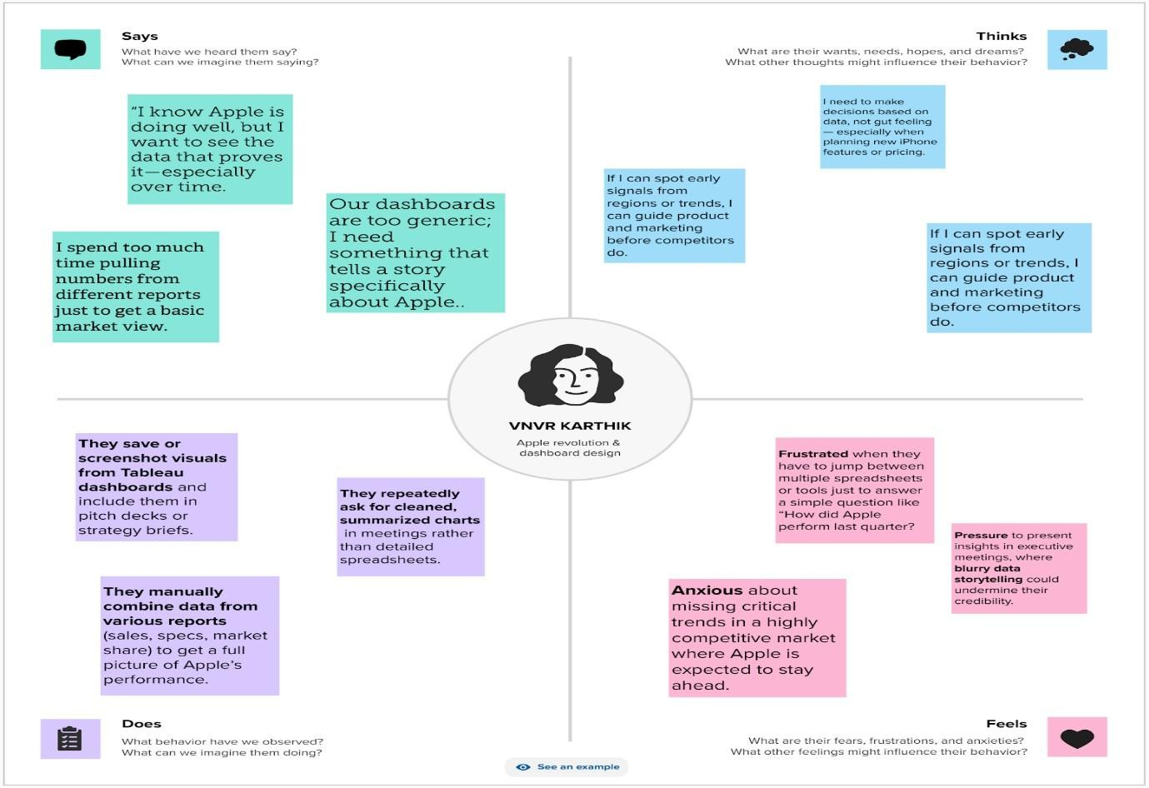

  - Brainstorming
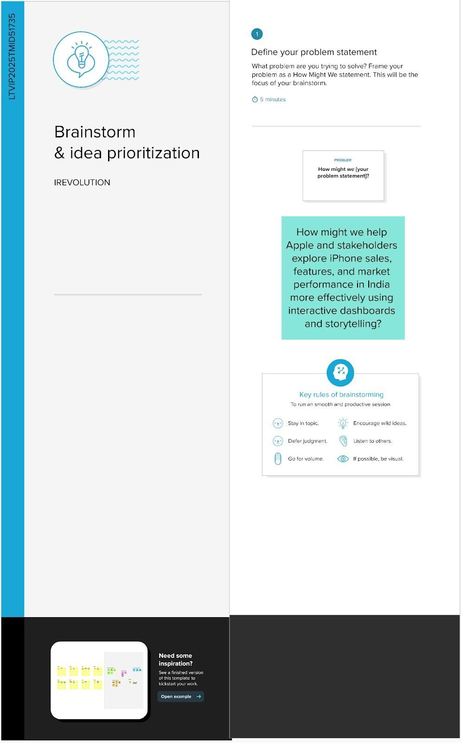

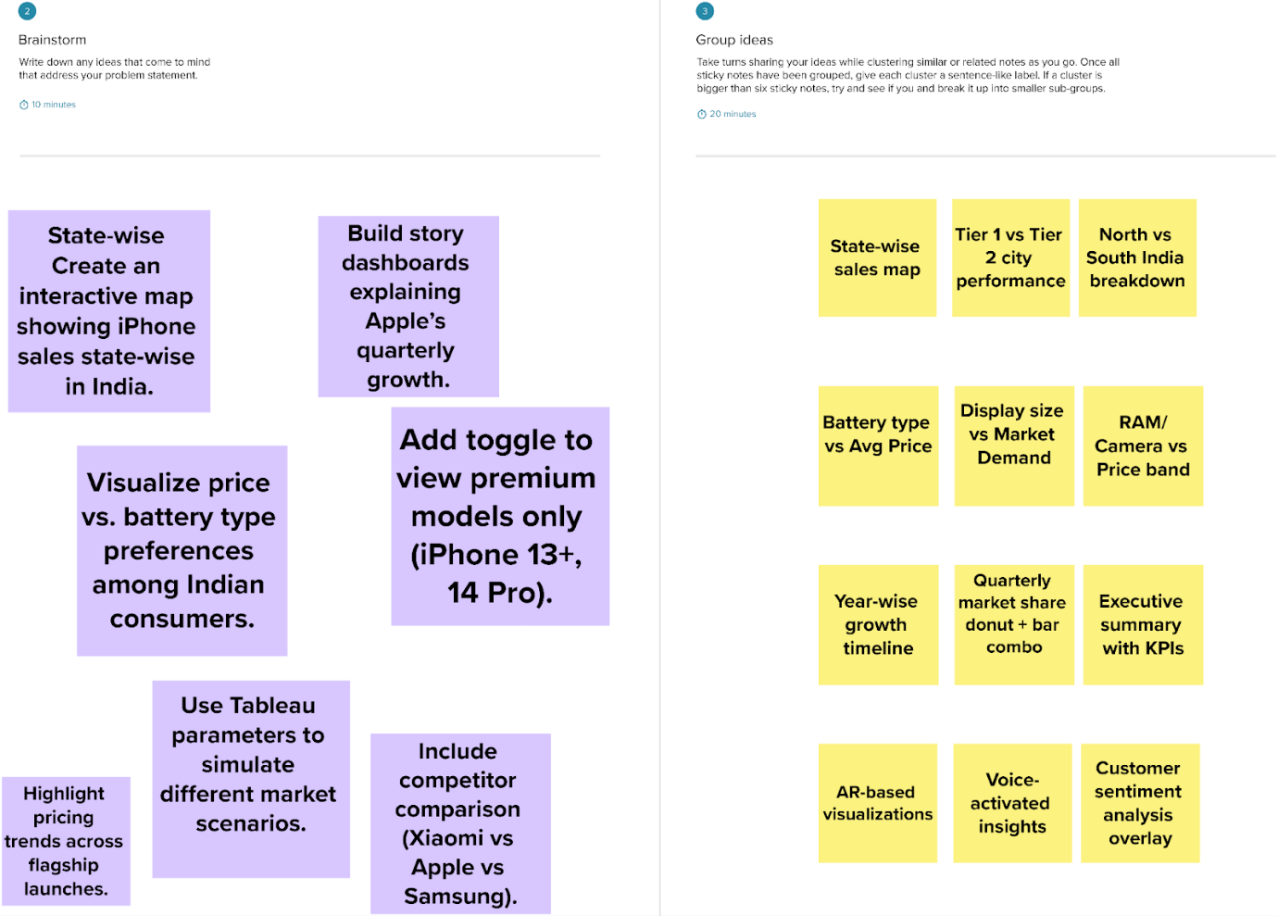

REQUIREMENT ANALYSIS
  - Customer Journey map

Stage | Need | Action | Touchpoint | Pain Point | Opportunity
Discover | Wants iPhone market trends | Searches Excel/market data | Emails, Files | Data is scattered | Single dashboard entry point
Explore | Needs regional & feature insights | Browses charts manually | Spreadsheets, BI tools | Time-consum ing | Filter-enabled Tableau dashboard
Engage | Wants to compare specs vs pricing | Tries custom visualizations | Excel formulas | Lacks interactivity | Pre-built price/spec dashboard
Decide | Prepares pitch for leadership | Screenshots graphs | Presentations | Dry data storytelling | Use Tableau story points with captions

  - Solution Requirement Functional Requirements:
Following are the functional requirements of the proposed solution.

FR  No. | Functional Requirement (Epic) | Sub Requirement (Story / Sub-Task)
FR-1 | Interactive KPI Dashboard | Displays revenue, units sold, active users, and discount percentage filtered by year and region.
FR-2 | Model & Spec Analytics | Allows users to compare iPhone models based on features like display size, battery type, RAM, and camera.
FR-3 | Quarterly Market Share Visualization | Displays brand-wise share in India across four quarters using donut and bar charts.
FR-4 | Pricing Pattern Insights | Visualizes average price distribution and discount trends by feature and battery type.
FR-5 | Geo-Map Representation | Shows Apple’s regional performance across Indian states.
FR-6 | Story-Based Dashboard Navigation | Sequential story view explaining Apple’s performance journey with narrative captions.

Non-functional Requirements:
Following are the non-functional requirements of the proposed solution.

FR  No. | Non-Functional Requirement | Description
NFR- 1 | Performance | Dashboards must load within 3–5 seconds even with filters applied.
NFR- 2 | Scalability | The framework should support future data addition (e.g., new models or regions).
NFR- 3 | Responsiveness | Dashboard layout should be usable on laptops and projectors during presentations.
NFR- 4 | Performance | The interface must be simple, readable, and require no technical background to explore.
NFR- 5 | Usability | Use a dark theme with eye-comfort colors and clear legends to reduce user fatigue.
NFR- 6 | Data Accuracy | Ensure calculations (KPIs, averages, comparisons) are correctly validated against source files.

  - Data Flow Diagram

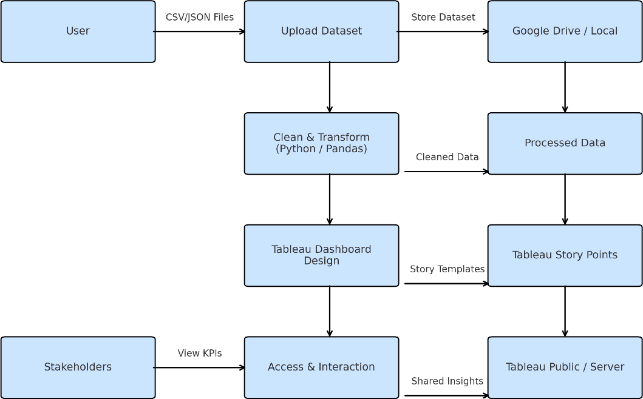

  - Technology Stack

Component | Tool/Technology | Purpose
Data Source | CSV, JSON files | Raw smartphone sales and specs data
Visualization | Tableau Desktop | Creating interactive dashboards and stories
Storage | Google Drive / Local | Storing raw and processed datasets
Collaboratio n | Google Docs, Slack | Team communication and report writing
Deployment | Tableau Public / Server | Dashboard sharing and stakeholder access

PROJECT DESIGN
  - Problem Solution Fit
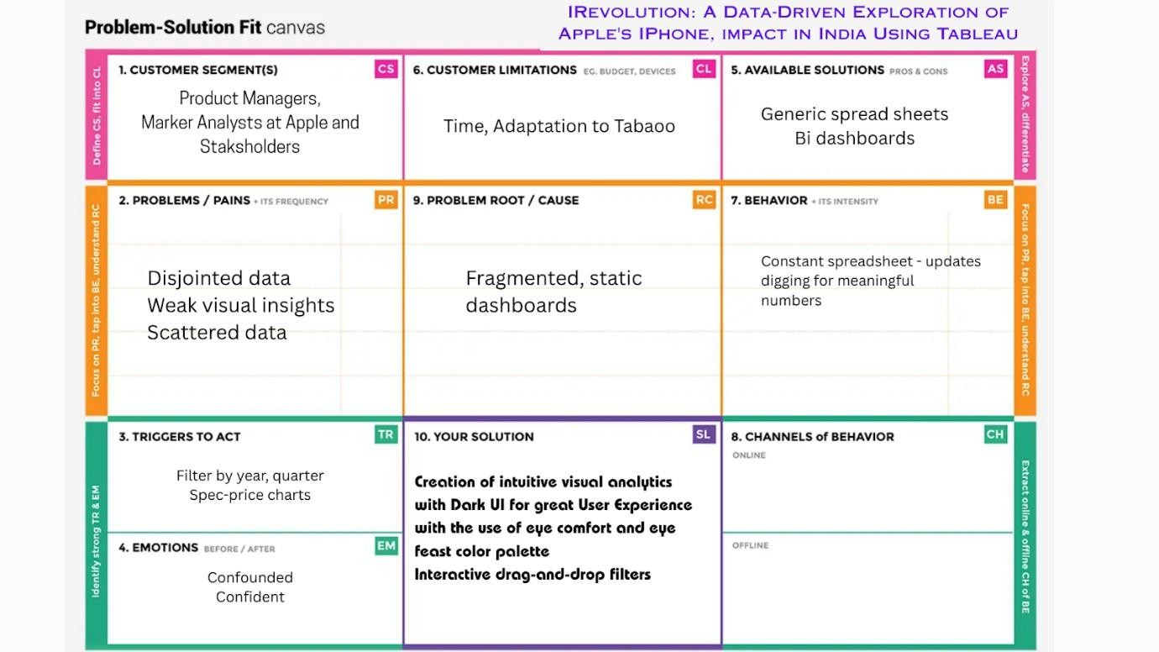
  - Proposed Solution

S.No. | Parameter | Description
1. | Problem Statement (Problem to be solved) | Apple and its stakeholders lack a centralized, interactive, and  story-driven way to understand iPhone’s feature-wise, region-wise, and price-wise impact in India. This limits confident, data-backed decisions.
0. | Idea / Solution description | Creation of intuitive visual analytics with Dark UI for great User experience with the use of eye comfort ond eye feast color palette  Interactive drag-and-drop filters
0. | Novelty / Uniqueness | Instead of traditional static reports, this solution uses story-driven dashboards with real-time interactivity. The dark UI is thoughtfully chosen to reduce eye strain and improve focus. KPIs are dynamically aligned to user-selected filters — not just fixed charts.

0. | Social Impact / Customer Satisfaction | Helps product and marketing teams make better decisions that align with consumer needs, especially in varied Indian markets.  Encourages a data-first mindset, improves visibility, and cuts analysis time
0. | Business Model (Revenue Model) | This solution can be packaged as a subscription-based internal tool or consultancy model where other OEMs or market agencies can adopt the dashboard framework tailored to their brand data.
0. | Scalability of the Solution | The dashboard framework is scalable to other countries, brands, or product categories. Only the dataset and labels need to be updated  — the core logic and layout remain reusable across contexts.

  - Solution Architecture
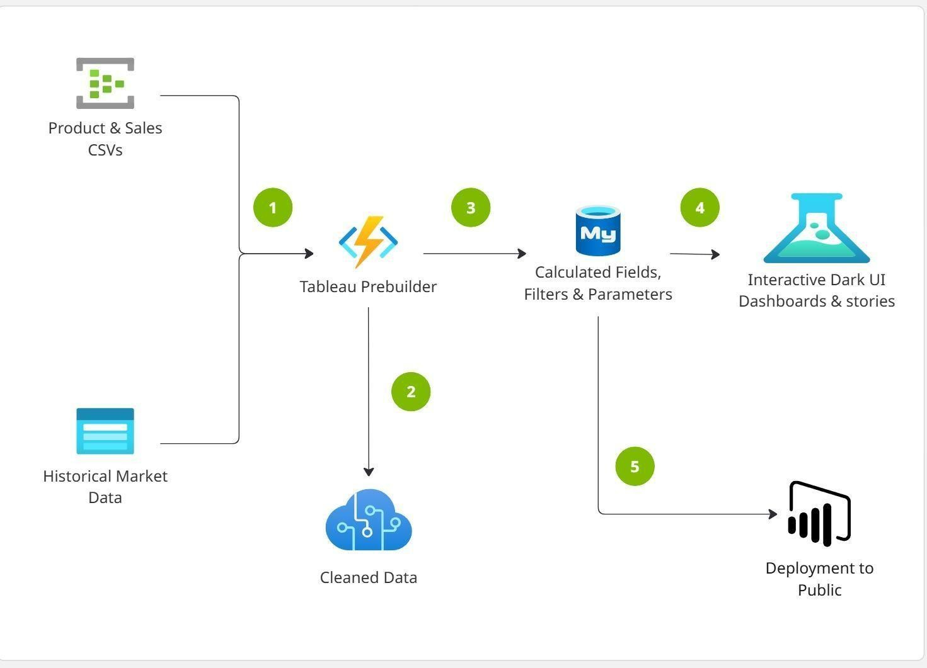

PROJECT PLANNING & SCHEDULING
  - Project Planning

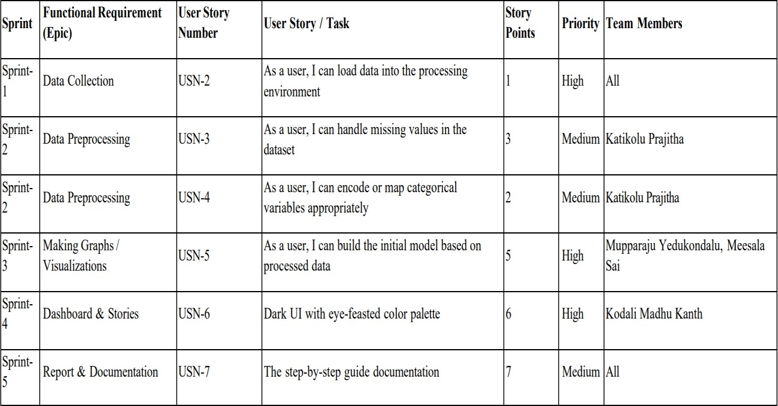

FUNCTIONAL AND PERFORMANCE TESTING
  - Performance Testing
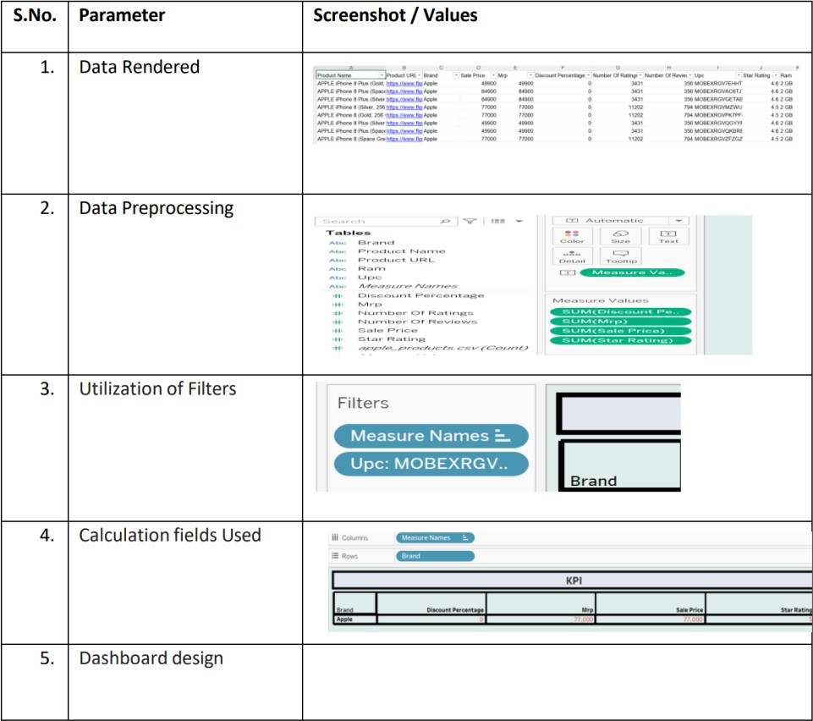
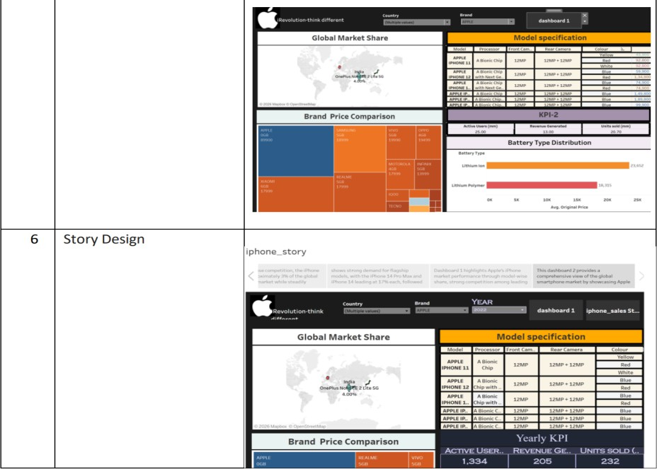

RESULTS
  - Output Screenshots WORKSHEETS:
Model Specification-
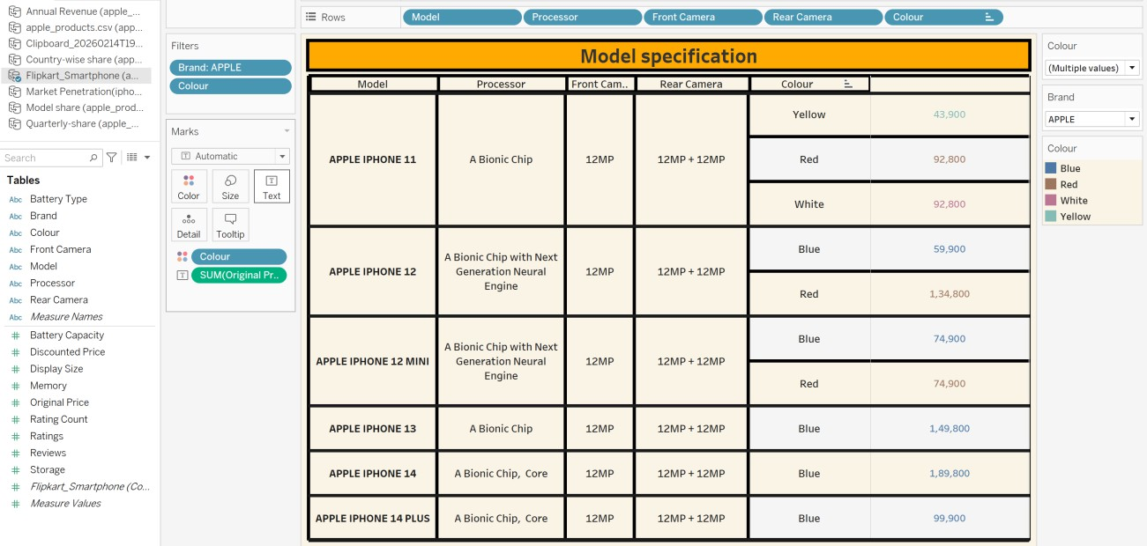

BrandPriceComparsion
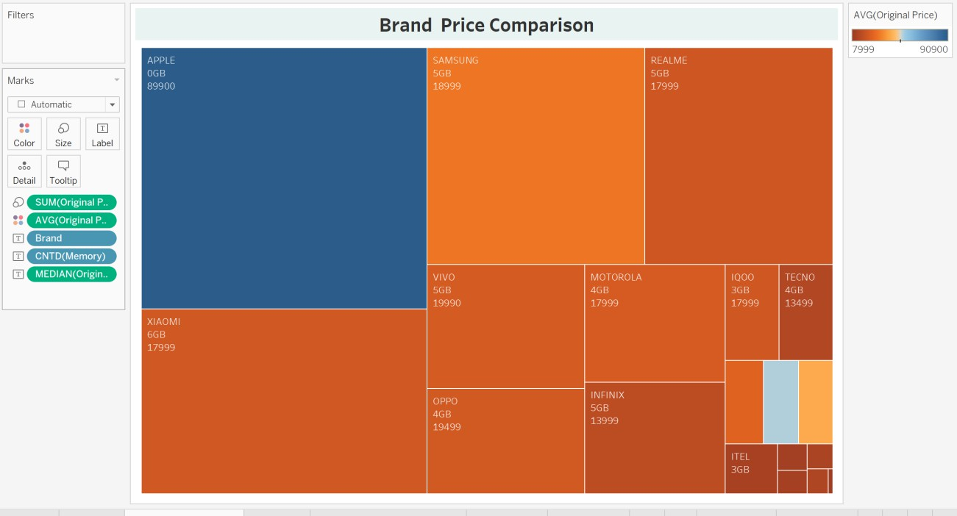

ModelwiseShare
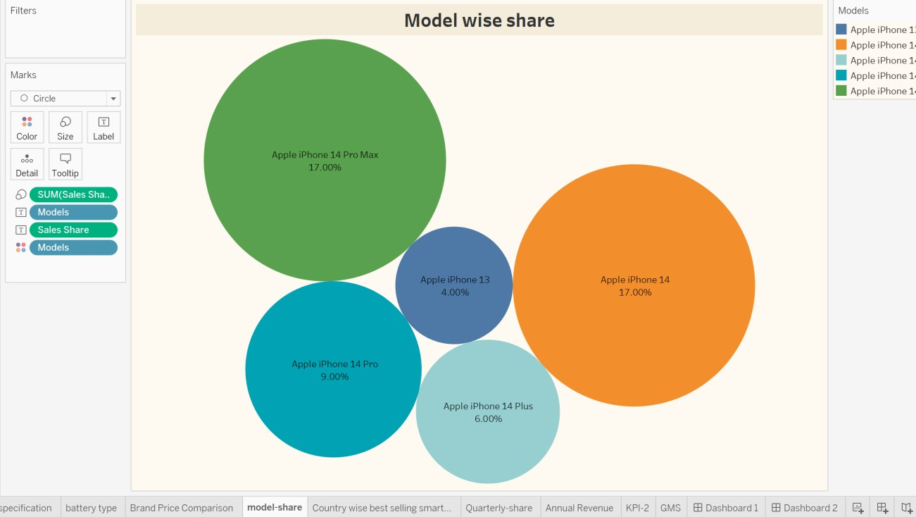

Countrywisebestselling
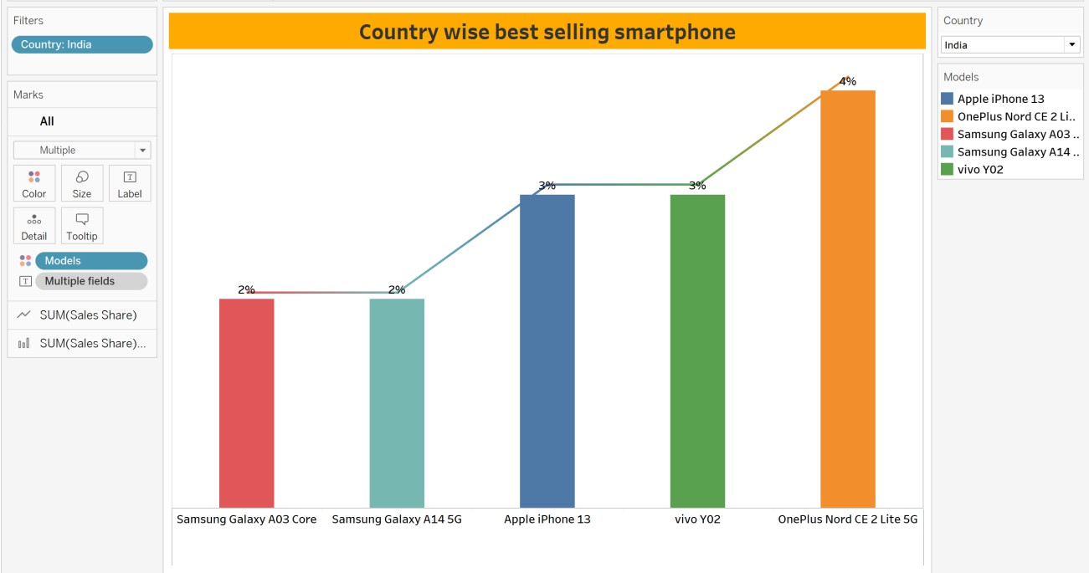

DASHBOARDS:
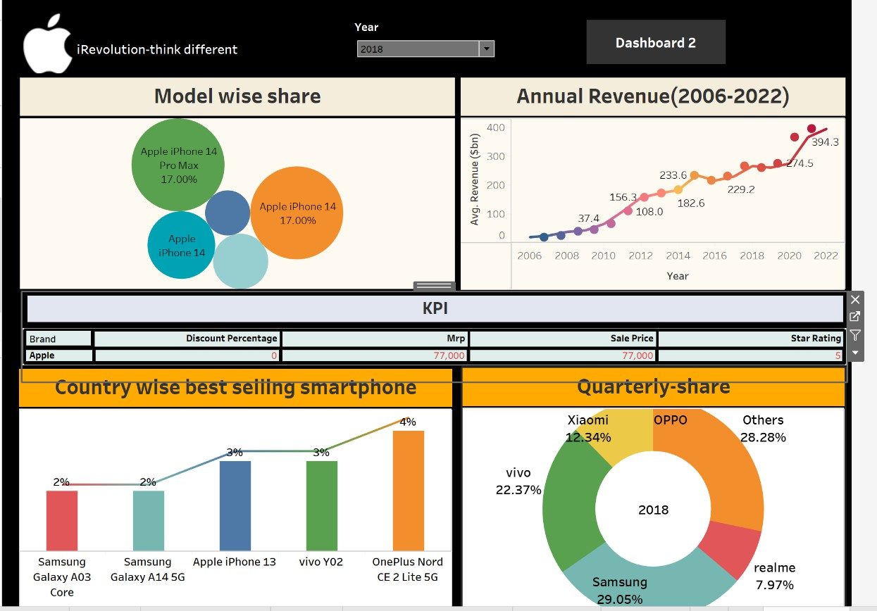
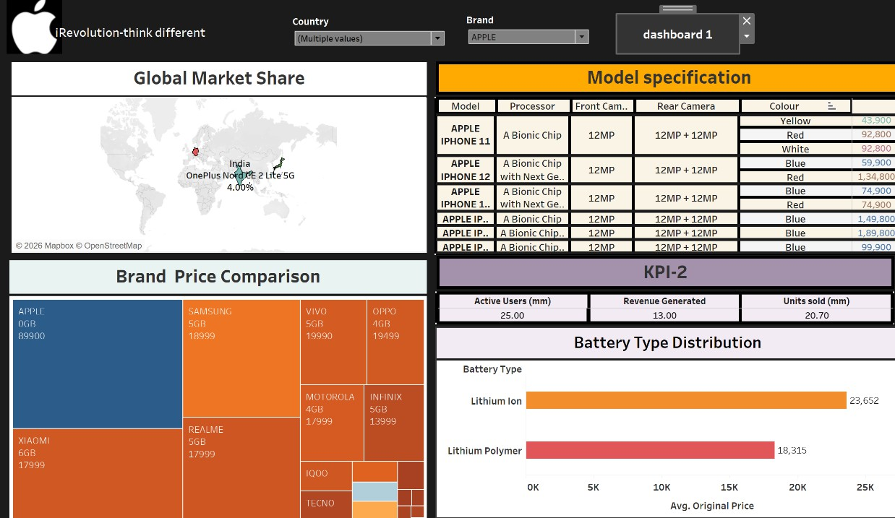

STORY:
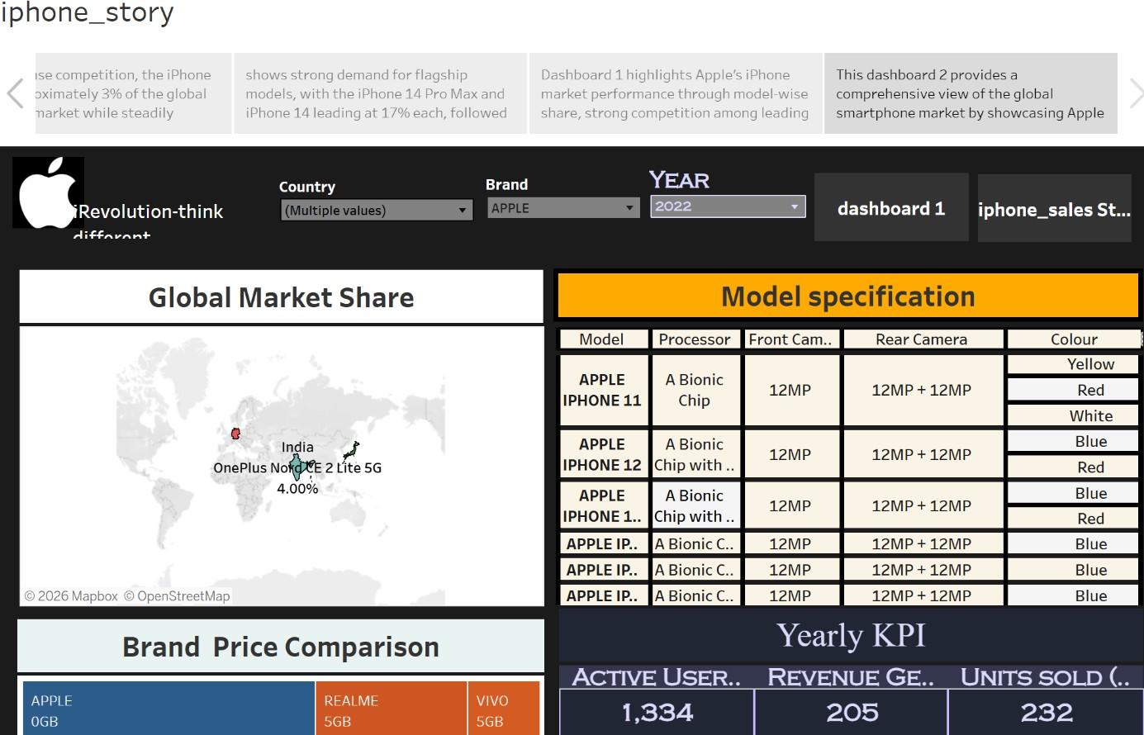

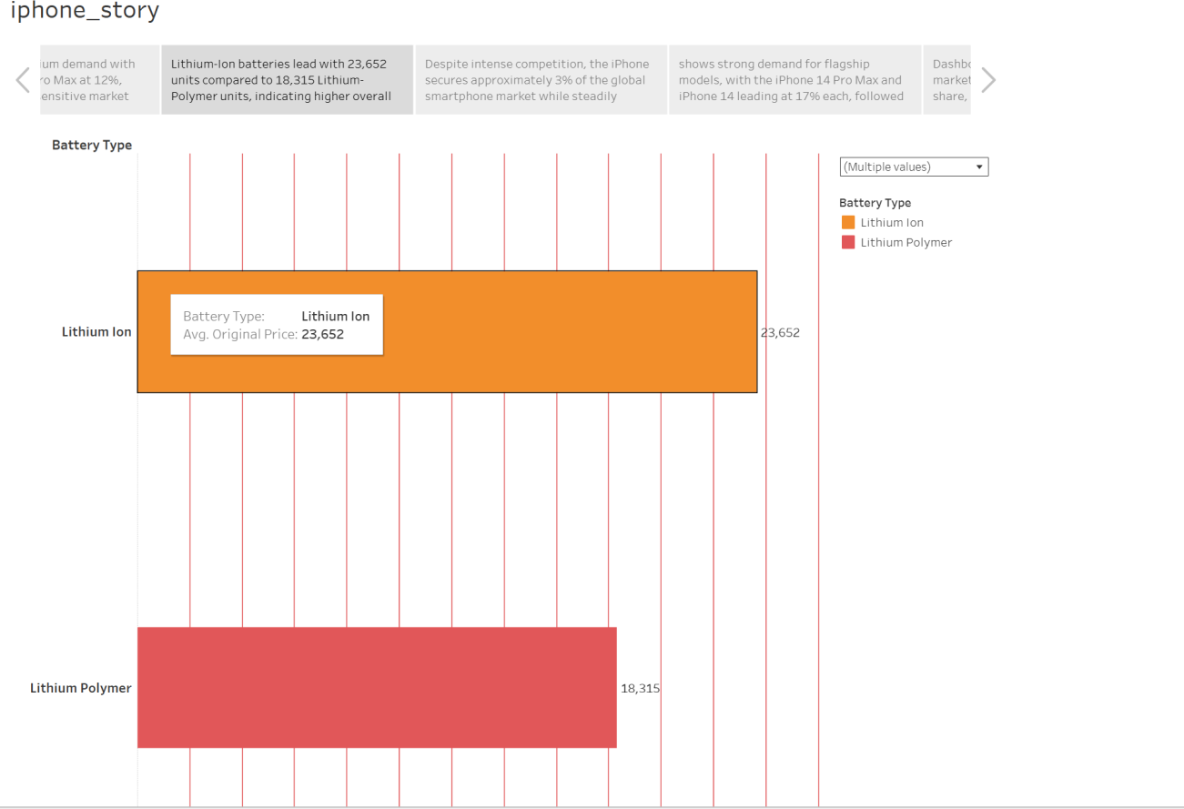

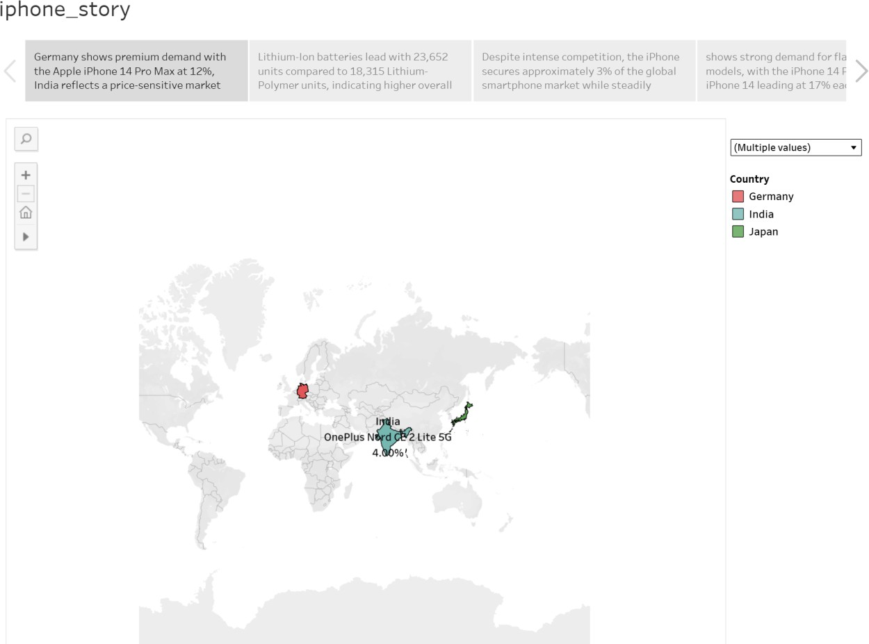

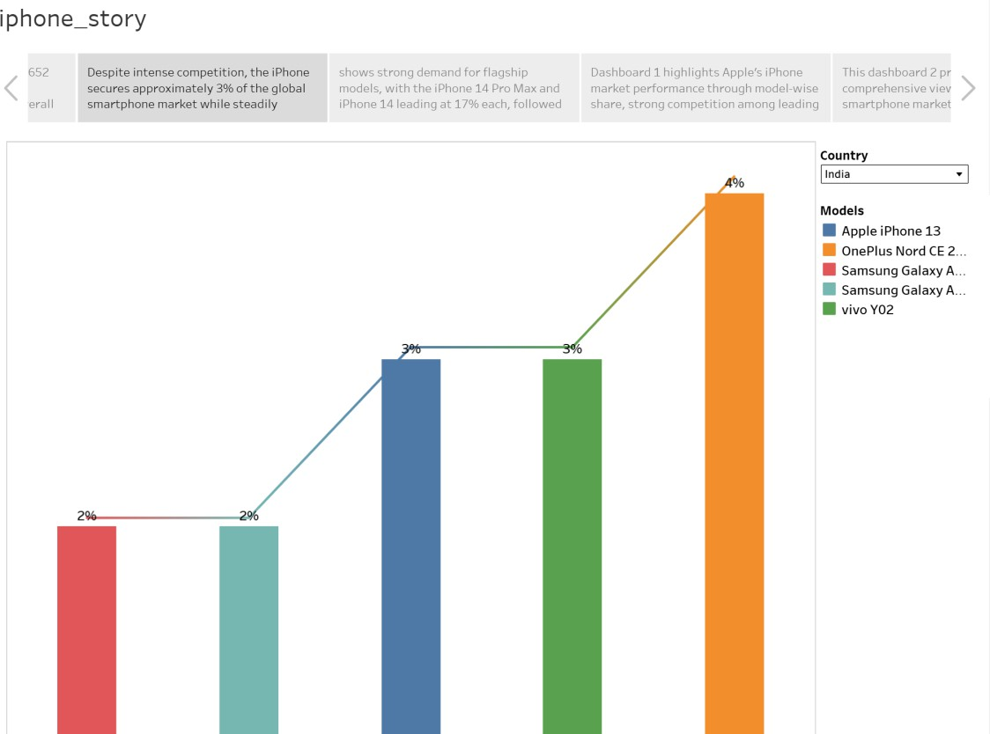

FLASK AND UI INTEGRATION:
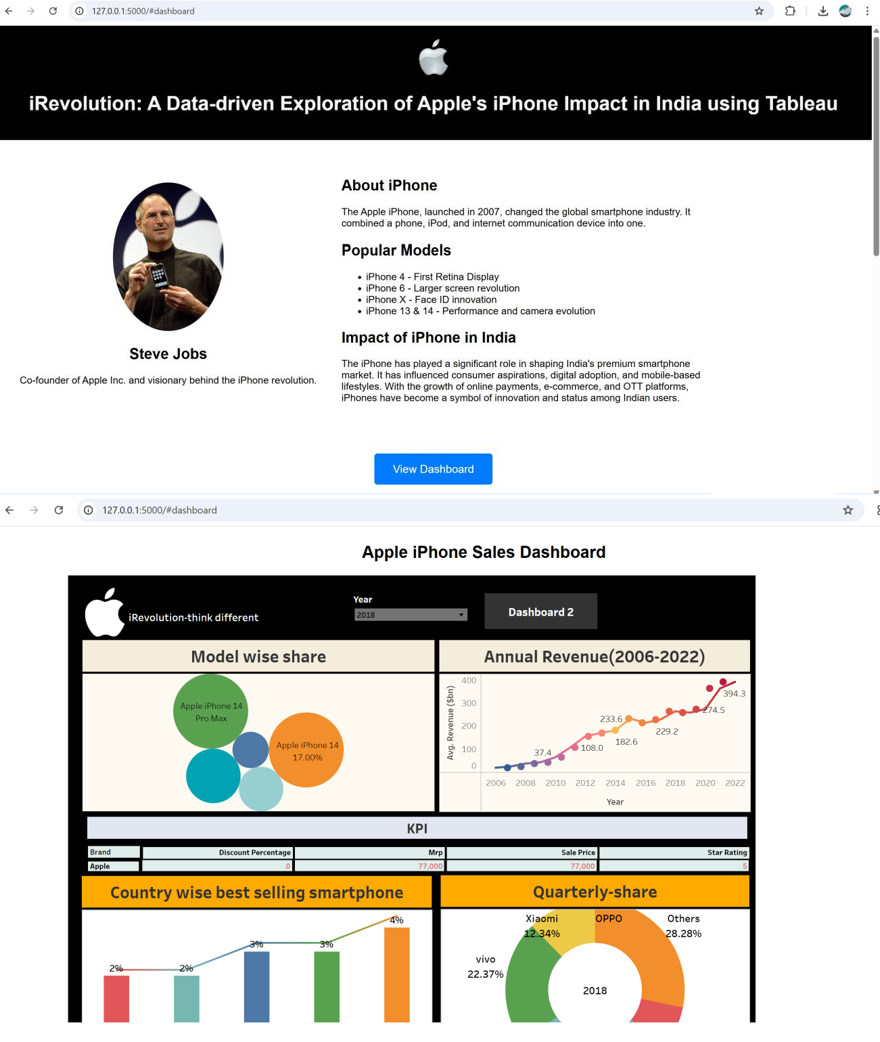

CODE:
App.py
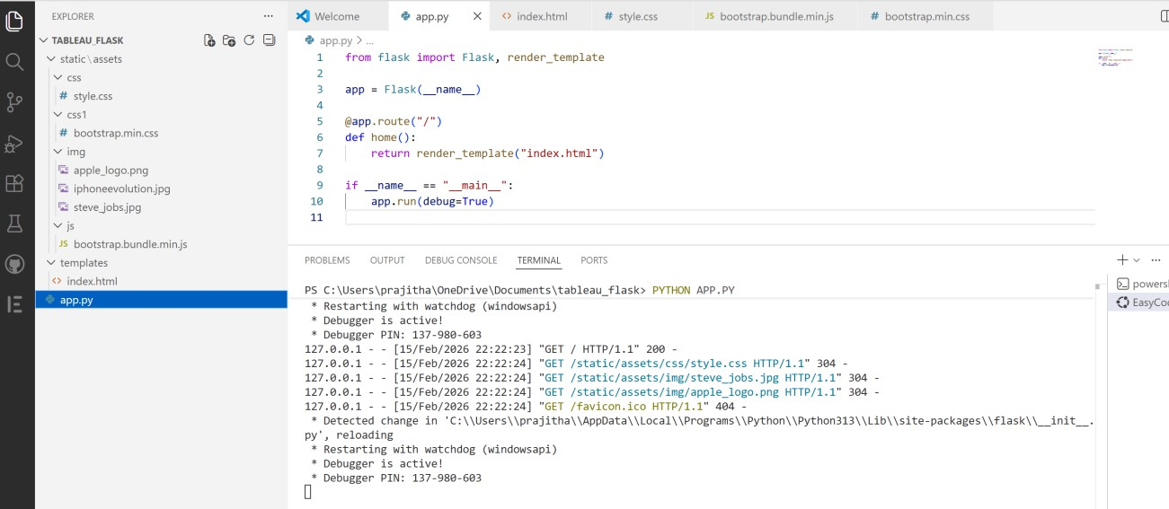

Index.html
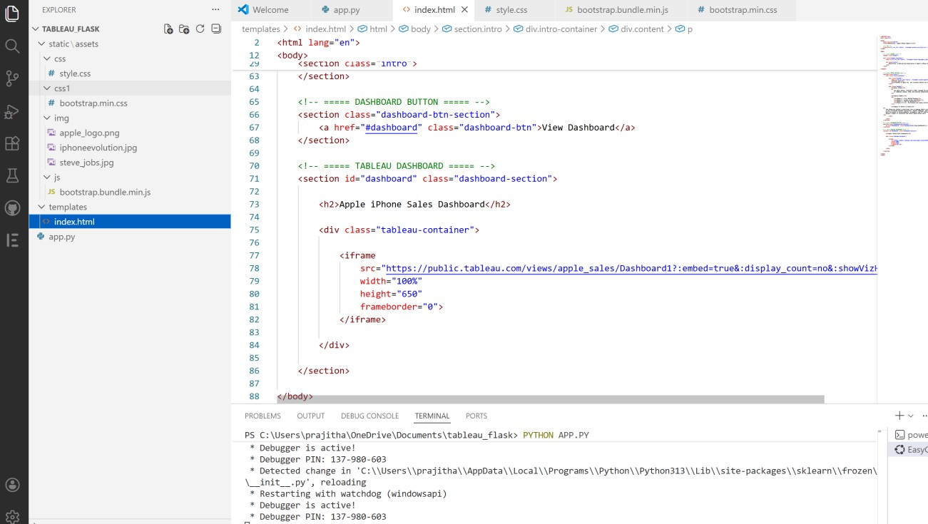

- ADVANTAGES & DISADVANTAGES

ADVANTAGES:
  - User-Friendly Dashboards: Intuitive interface with dark-themed visuals that reduce eye strain and enhance readability.

Interactive Insights: Real-time filtering and data slicing allow users to extract exactly what they need without manual intervention.
  - Reusable Framework: The dashboard model can be reused for other smartphone brands or markets by simply updating the dataset.
  - Data-Driven Decision Making: Helps strategists, marketers, and executives make smarter, evidence-based decisions.

Time-Saving: Reduces the manual workload for analysts by providing ready-to-explore visualizations.
- DISADVANTAGES:

Platform Limitation: Tableau Public may limit some functionality such as real-time backend connection and publishing privacy.
  - Dependence on Data Accuracy: Insights are only as good as the quality of input data; inaccurate or outdated datasets could mislead.
  - Static Structure in Story: While dashboards are interactive, Tableau stories have limited flexibility in dynamic narration.

CONCLUSION
The iRevolution project successfully demonstrates how data visualization, combined with
user-centered design, can drive meaningful insights into Apple’s iPhone performance in India. By integrating sales, pricing, feature-based specs, and regional market data into interactive Tableau dashboards, the project not only simplifies complex analytics but also empowers decision-makers to act with confidence. This end-to-end effort—from ideation to deployment—shows the real-world value of design thinking and data storytelling in business intelligence.

FUTURE SCOPE
- Multi-brand Integration: Extend the current dashboard to include competitor analysis (e.g., Samsung, Xiaomi).
- Real-Time Data Connection: Integrate live data sources (APIs or Google Sheets) to keep the dashboards updated automatically.
- Mobile Optimization: Redesign dashboards for optimal viewing on tablets and mobile devices.
- AI-Powered Forecasting: Use predictive analytics to project future sales, pricing trends, or regional performance.
- Sentiment Analysis Layer: Add customer feedback and review analysis to supplement numeric insights with qualitative data.

APPENDIX
Dataset Link
https://docs.google.com/spreadsheets/d/1p1ZWaYcEuFl5UNFcmNvpkXi3JnoHamut/edit?gid=18774464 87#gid=1877446487
GitHub & Project Demo Link
https://github.com/Prajitha-Katikolu/iRevolution-A-Data-driven-Exploration-of-Apple-s- iPhone-Impact-in-India-using-Tableau

